AI-Powered Job Recruitment & Candidate Management System (AIRCMS)
1. Abstract
The AI-Powered Job Recruitment & Candidate Management System (AIRCMS) is a cloud-based recruitment management platform developed using the Salesforce CRM platform. The system centralizes recruitment operations including job posting, candidate application tracking, interview scheduling, and hiring approvals within a unified digital environment.
AIRCMS integrates artificial intelligence capabilities using Agentforce, which assists recruiters in evaluating candidate profiles, generating intelligent summaries, identifying potential hiring risks, and recommending hiring decisions. This reduces manual resume screening effort and improves hiring accuracy.
Traditional recruitment methods often rely on spreadsheets, emails, and multiple disconnected tools, which lead to inefficiencies and lack of transparency. AIRCMS eliminates these issues by providing a centralized platform that ensures structured recruitment workflows, consistent evaluation processes, and better collaboration between recruiters and hiring managers.
The system also provides automation features such as approval workflows, candidate scoring, automated notifications, and recruitment dashboards that allow organizations to monitor recruitment performance effectively.

2. Introduction
Recruitment plays a critical role in the success of any organization. Companies must continuously identify, evaluate, and hire talented candidates to maintain business growth and competitiveness.
However, many organizations still rely on manual recruitment systems such as spreadsheets, emails, and basic applicant tracking tools. These traditional approaches often result in several problems such as duplicate candidate records, delayed interview scheduling, poor communication between recruiters and hiring managers, and inefficient candidate evaluation.
Modern organizations are now adopting digital recruitment platforms that automate hiring workflows and improve decision-making using artificial intelligence technologies.
The AI-Powered Job Recruitment & Candidate Management System (AIRCMS) is designed to address these challenges. Built on the **Salesforce CRM platform, the system provides centralized recruitment management with AI-driven decision support.
AIRCMS improves recruitment efficiency by automating workflows, providing AI-based candidate analysis, and enabling real-time recruitment monitoring.

3. Literature Review
Several recruitment management systems have been developed to improve hiring processes. Traditional Applicant Tracking Systems (ATS) allow organizations to store candidate information and track job applications.
However, many of these systems lack intelligent features for candidate evaluation. Modern recruitment platforms are now integrating artificial intelligence to automate resume screening, candidate ranking, and predictive hiring analytics.
AI-based recruitment tools can analyze candidate skills, experience, and job requirements to recommend suitable candidates. This reduces recruiter workload and improves hiring quality.
AIRCMS builds upon these advancements by integrating AI capabilities through Agentforce AI within the Salesforce ecosystem, providing intelligent recruitment support while maintaining secure enterprise data management.

4. Problem Statement
Organizations face multiple challenges when managing recruitment using manual or disconnected tools.
Common problems include:
- Duplicate candidate records
- Lost or untracked job applications
- Delays in scheduling interviews
- Lack of standardized candidate evaluation
- Poor tracking of recruitment performance
- Limited visibility into hiring progress
These issues reduce recruiter productivity and increase the time required to fill job positions.
Therefore, there is a need for a centralized recruitment management system that automates hiring workflows, improves candidate evaluation, and provides intelligent decision-making support.

5. Objectives of the Project
The main objectives of the AIRCMS project are:
5.1 Centralized Recruitment Management
To manage candidate records, job openings, and recruitment activities within a unified system.
5.2 Recruitment Workflow Automation
To automate recruitment activities such as application tracking, interview scheduling, and hiring approvals.
5.3 AI-Driven Hiring Intelligence
To use artificial intelligence for candidate scoring, hiring recommendations, and risk analysis.
5.4 Improved Recruitment Tracking
To enable recruiters and managers to monitor recruitment progress using dashboards and reports.
5.5 Secure Data Access
To implement role-based security to protect recruitment data.

6. Scope of the Project
The AIRCMS system focuses on improving recruitment management within organizations.
The system includes:
- Job opening management
- Candidate application tracking
- Interview process monitoring
- AI-based candidate analysis
- Offer approval workflows
- Recruitment analytics dashboards
The system is designed primarily for organizations receiving large volumes of job applications.

7. System Overview
AIRCMS provides an integrated recruitment management platform where recruiters, hiring managers, and administrators collaborate to manage hiring processes efficiently.
The system stores recruitment data using Salesforce objects and automates processes using Salesforce automation tools.
The system also integrates Agentforce AI to provide intelligent insights for candidate evaluation.

8. System Architecture
The AIRCMS architecture consists of five main layers.
8.1 Frontend Layer
The frontend interface is built using Salesforce Lightning Experience, providing user-friendly dashboards and forms for recruiters and hiring managers.
Users can:
- View candidate profiles
- Manage job openings
- Track recruitment progress
- Monitor interview schedules

8.2 Backend Layer
The backend layer handles recruitment logic and workflow automation using Salesforce tools:
- Custom Objects
- Flow Builder
- Approval Processes
- Validation Rules

8.3 Data Layer
The data layer stores recruitment data in structured Salesforce objects such as:
- Candidate
- Job Opening
- Application
- Interview
- Offer
Relationships between objects allow the system to track the entire recruitment lifecycle.

8.4 AI Layer
The AI layer integrates Agentforce AI to generate intelligent insights including:
- Candidate summaries
- Candidate scoring
- Hiring risk analysis
- Hiring recommendations

8.5 Security Layer
Security is implemented using:
- Profiles
- Roles
- Permission sets
- Record-level access control
These ensure that only authorized users can access recruitment data.

9. Technologies Used
9. System Architecture Diagram
The architecture of the AI-Powered Job Recruitment & Candidate Management System (AIRCMS) is designed using a layered approach to ensure scalability, security, and efficient data processing.
The system is developed on the **Salesforce platform and integrates artificial intelligence using **Agentforce AI.
The architecture consists of the following major components:
9.1 User Layer
The user layer represents the individuals who interact with the system.
The primary users include:
- Recruiters
- Hiring Managers
- HR Administrators
These users access the system through the Salesforce Lightning Experience interface, which provides dashboards, forms, and reports to manage recruitment activities.

9.2 Application Layer
The application layer contains the business logic of the recruitment system. It handles recruitment workflows such as candidate application tracking, interview scheduling, and hiring approvals.
This layer uses Salesforce automation tools such as:
- Flow Builder
- Approval Processes
- Validation Rules
- Apex Logic (if used)
These tools automate recruitment tasks and reduce manual intervention.

9.3 Data Layer
The data layer manages the storage and organization of recruitment data. The system uses Salesforce custom objects to store information related to recruitment.
Main objects include:
- Candidate
- Job Opening
- Application
- Interview
- Offer
Relationships between these objects ensure proper tracking of candidate progress during recruitment.

9.4 AI Intelligence Layer
The AI layer integrates Agentforce AI, which provides intelligent insights for recruiters.
AI functions include:
- Candidate profile summarization
- Candidate scoring
- Hiring risk analysis
- Hiring recommendations
This layer helps recruiters make faster and more informed hiring decisions.

9.5 Security Layer
The security layer ensures protection of recruitment data.
Security mechanisms include:
- User Profiles
- Roles and Role Hierarchy
- Permission Sets
- Record-level Access Control
These security features ensure that users can only access information relevant to their role.

Example Architecture Diagram (You Can Draw This in Report)
+----------------------+
| Recruiters / HR |
| Hiring Managers |
+----------+-----------+
|
v
+----------------------+
| Salesforce Lightning |
| Interface |
+----------+-----------+
|
v
+----------------------+
| Application Layer |
| Flow Builder |
| Approval Processes |
| Validation Rules |
+----------+-----------+
|
v
+----------------------+
| Data Layer |
| Candidate Object |
| Job Opening Object |
| Interview Object |
| Offer Object |
+----------+-----------+
|
v
+----------------------+
| AI Layer |
| Agentforce AI |
| Candidate Scoring |
| Hiring Suggestions |
+----------+-----------+
|
v
+----------------------+
| Security Layer |
| Profiles & Roles |
| Permission Sets |
+----------------------+
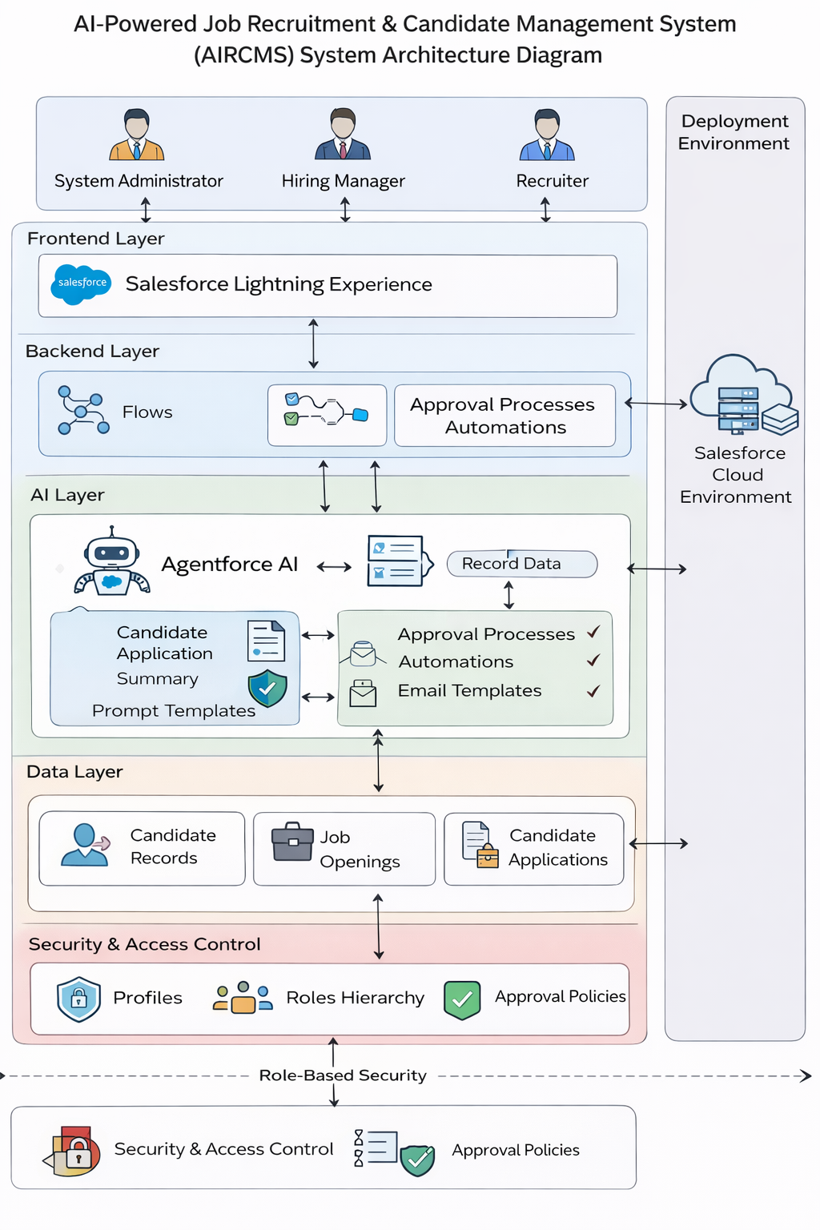
Technology | Purpose
Salesforce CRM | Core platform
Agentforce AI | Artificial intelligence integration
Salesforce Lightning | User interface
Flow Builder | Workflow automation
Approval Processes | Offer approval management
Email Templates | Automated communication

10. System Workflow
The AIRCMS workflow consists of the following steps:
- Recruiters create job openings.
- Candidates apply for job positions.
- Candidate applications are stored in Salesforce records.
- AI analyzes candidate profiles.
- Candidate scores are generated.
- Recruiters shortlist candidates.
- Interviews are scheduled.
- Selected candidates receive job offers.
- High salary offers trigger approval workflows.
- Hiring managers approve or reject offers.

- Database Design
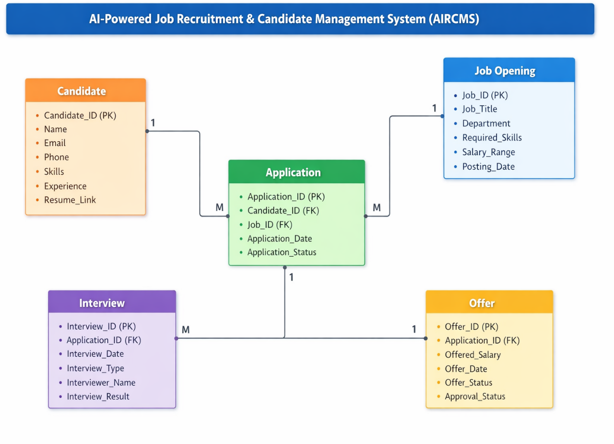
ER Diagram for AIRCMS
1. Overview of ER Diagram
The Entity-Relationship (ER) Diagram represents the logical structure of the database used in the AI-Powered Job Recruitment & Candidate Management System (AIRCMS).
It illustrates how different entities such as candidates, job openings, applications, interviews, and job offers interact with each other.
The ER diagram helps in:
- Designing the database structure
- Defining relationships between entities
- Ensuring data integrity and consistency
- Simplifying recruitment workflow management
In the AIRCMS system, recruitment data is stored using Salesforce custom objects that are connected through relationships.

2. Main Entities in AIRCMS
2.1 Candidate Entity
This entity stores information about job applicants.
Attributes
- Candidate_ID (Primary Key)
- Candidate_Name
- Email
- Phone
- Skills
- Experience
- Resume_Link
- Application_Status
Each candidate can apply for multiple job openings.

2.2 Job Opening Entity
This entity stores information about job vacancies created by recruiters.
Attributes
- Job_ID (Primary Key)
- Job_Title
- Department
- Required_Skills
- Salary_Range
- Job_Description
- Posting_Date
A job opening can receive multiple candidate applications.

2.3 Application Entity
This entity connects candidates with job openings.
Attributes
- Application_ID (Primary Key)
- Candidate_ID (Foreign Key)
- Job_ID (Foreign Key)
- Application_Date
- Application_Status
This entity forms a many-to-many relationship between candidates and job openings.

2.4 Interview Entity
This entity stores interview details for candidates.
Attributes
- Interview_ID (Primary Key)
- Application_ID (Foreign Key)
- Interview_Date
- Interview_Type
- Interviewer_Name
- Interview_Result
A candidate application may have multiple interviews.

2.5 Offer Entity
This entity manages job offers given to selected candidates.
Attributes
- Offer_ID (Primary Key)
- Application_ID (Foreign Key)
- Offered_Salary
- Offer_Date
- Offer_Status
- Approval_Status
Offers may require approval through workflow automation.

3. ER Diagram Structure
You can draw the ER diagram like this:
Candidate
---------
Candidate_ID (PK)
Name
Email
Phone
Skills
Experience
Resume_Link
|
| 1
|
|
| M
Application
------------
Application_ID (PK)
Candidate_ID (FK)
Job_ID (FK)
Application_Date
Application_Status
|
| M
|
| 1
Job Opening
------------
Job_ID (PK)
Job_Title
Department
Required_Skills
Salary_Range
Posting_Date
|
| 1
|
| M
Interview
-----------
Interview_ID (PK)
Application_ID (FK)
Interview_Date
Interview_Type
Interviewer_Name
Interview_Result
|
| 1
|
| 1
Offer
------
Offer_ID (PK)
Application_ID (FK)
Offered_Salary
Offer_Date
Offer_Status
Approval_Status

4. Relationship Explanation
Candidate → Application
One candidate can submit multiple applications for different job openings.
Relationship:
One-to-Many (1:M)

Job Opening → Application
One job opening can receive many candidate applications.
Relationship:
One-to-Many (1:M)

Application → Interview
A candidate application can have multiple interview rounds.
Relationship:
One-to-Many (1:M)

Application → Offer
Only selected applications receive a job offer.
Relationship:
One-to-One (1:1)

5. Benefits of the ER Design
The ER model helps AIRCMS achieve:
- Efficient recruitment data management
- Structured candidate tracking
- Reduced data duplication
- Improved system scalability
- Better relationship management between recruitment entities

Main Objects
- Candidate
- Job Opening
- Application
- Interview
- Offer
Each object contains specific fields such as:
- Candidate Name
- Email
- Skills
- Job Title
- Interview Date
- Offer Salary
Relationships connect candidates with job openings and interviews.

12. Implementation
The system was implemented in several stages.
Step 1
Creation of Salesforce custom objects.
Step 2
Configuration of relationships and fields.
Step 3
Implementation of workflow automation using Flow Builder.
Step 4
Development of approval processes.
Step 5
Integration of Agentforce AI.
Step 6
Dashboard creation.

13. Testing
Testing ensured system reliability and correctness.
Testing included:
- Unit testing
- Workflow testing
- Approval process testing
- Email notification testing
- AI output validation

14. Results
The AIRCMS system significantly improved recruitment management.
Key results include:
- Reduced manual screening effort
- Faster recruitment processes
- Improved hiring accuracy
- Better collaboration between recruiters and managers

15. Advantages
- Centralized recruitment management
- Automated workflows
- AI-driven decision support
- Improved recruiter productivity
- Secure data access

16. Limitations
16. Screenshots of System Implementation
Screenshots play an important role in demonstrating the actual implementation of the system in the Salesforce environment. These screenshots help reviewers understand how the system works in real-world scenarios.
The following screenshots should be included in the project report.

16.1 Salesforce Login Page
This screenshot shows the login interface used by authorized users to access the AIRCMS system.
Screenshot should include:
- Salesforce login interface
- Username and password fields
- Organization login portal
Caption Example:
Figure 1: Salesforce Login Interface

16.2 AIRCMS Lightning Application Dashboard
This screenshot displays the main dashboard of the AIRCMS application within Salesforce.
The dashboard provides quick access to:
- Job openings
- Candidate records
- Interview schedules
- Recruitment analytics
Caption Example:
Figure 2: AIRCMS Recruitment Dashboard

16.3 Candidate Object Page
This screenshot shows the candidate management interface where recruiters can create and manage candidate records.
The page includes fields such as:
- Candidate Name
- Email Address
- Phone Number
- Skills
- Resume Link
- Application Status
Caption Example:
Figure 3: Candidate Object Record Page

16.4 Job Opening Management Page
This screenshot shows how recruiters create and manage job openings in the system.
Fields include:
- Job Title
- Department
- Required Skills
- Salary Range
- Job Description
Caption Example:
Figure 4: Job Opening Creation Interface

16.5 Application Tracking Page
This screenshot demonstrates how candidate applications are linked to job openings and tracked within the system.
Recruiters can view:
- Applied candidates
- Application status
- Screening results
Caption Example:
Figure 5: Candidate Application Tracking Page

16.6 Interview Scheduling Page
This screenshot displays the interface used to schedule interviews.
Information includes:
- Interview date and time
- Interviewer name
- Interview status
Caption Example:
Figure 6: Interview Scheduling Interface

16.7 Offer Approval Workflow
This screenshot shows the approval process triggered when a job offer exceeds a predefined salary threshold.
The approval process allows hiring managers to:
- Approve the offer
- Reject the offer
- Request modifications
Caption Example:
Figure 7: Offer Approval Workflow

16.8 AI Candidate Analysis
This screenshot demonstrates how Agentforce AI analyzes candidate profiles and generates intelligent insights.
The AI-generated results may include:
- Candidate summary
- Candidate score
- Hiring recommendation
Caption Example:
Figure 8: AI-Based Candidate Evaluation

16.9 Recruitment Analytics Dashboard
This screenshot displays recruitment analytics generated using Salesforce reports and dashboards.
Key metrics include:
- Total applications received
- Candidates shortlisted
- Interviews conducted
- Offers issued
Caption Example:
Figure 9: Recruitment Analytics Dashboard

16.10 Email Notification Automation
This screenshot demonstrates automated email alerts triggered during recruitment workflows.
Examples include:
- Interview confirmation emails
- Offer approval notifications
- Candidate status updates
Caption Example:
Figure 10: Automated Email Notification

- Requires Salesforce platform access
- AI analysis depends on candidate data quality
- Initial system setup requires Salesforce knowledge

17. Future Enhancements
Possible future improvements include:
- Resume parsing using AI
- Integration with job portals
- AI interview analysis
- Mobile recruitment application
- Advanced recruitment analytics

18. GitHub Documentation
The project source code and documentation are maintained using GitHub.
Repository Contents
The GitHub repository includes:
- Project documentation
- Salesforce configuration files
- Database schema
- System architecture diagrams
- Screenshots of system implementation
Repository Structure
AIRCMS
│
├── Documentation
├── Architecture
├── Salesforce_Config
├── Screenshots
└── README.md
GitHub Usage
GitHub was used for:
- Version control
- Project documentation
- Collaboration between team members
- Backup of project configurations

19. Conclusion
The AI-Powered Job Recruitment & Candidate Management System provides a modern solution for managing recruitment processes efficiently.
By combining the automation capabilities of Salesforce with the intelligence of Agentforce AI, the system enables organizations to streamline hiring workflows, improve candidate evaluation, and make data-driven hiring decisions.
The system reduces manual effort, improves transparency in recruitment operations, and enhances collaboration between recruiters and hiring managers.

